**Project Report on**

**Design and Development of Smart Campus ERP System**



**A Project report presented to the National University in partial fulfilment of the requirement for the degree of B.Sc. (Hon’s) in Computer Science & Engineering.**

**Submitted By**

**Mohammad Hafijul Islam**

**Registration No: 14502000922  
Session: 2014-2015**

**Department of Computer Science and Engineering**

**Institute of Science and Technology**

**National University, Bangladesh**

**December 2018**

**Declaration**

I here hereby, declare that the project work entitled “**Design and Development of Smart Campus ERP System**” is a record of work done by us under the guidance of **Lutfi Habiba**, Lecturer, Department of Computer Science and Engineering, Institute of Science and Technology. I also declare that the results embodied in this project have not been submitted to any other University or Institute for the award of any degree or diploma.

Signature Signature

**____________________ _________________________**

**Lutfi Habiba Mohammad Hafijul Islam**

(Supervisor) (Candidate)

**Approval**

This project report entitled **“Design and Development of Smart Campus ERP System”** prepared and submitted by **Mohammad Hafijul Islam** (Registration No: 14502000922) to the Department of Computer Science and Engineering, has been examined and recommended for approval and acceptance as to its style and contents.

**_____________________________ ____________________________**

**Examiner Supervisor**

**Lutfi Habiba**

**(Lecturer)**

Dept. of Computer Science and Engineering

Institute of Science and Technology.

**Date: Date:**

**Acknowledgement**

I satisfied that the successful completion of any task would be incomplete without the mention of people whose constant and unending co-operation made it possible, whose constant guidance and encouragement crown all efforts with success.

I would like to thank **Almighty Allah**, the most merciful for keeping his blessing on us in every sphere of life.

I am grateful to my guide teacher & supervisor **Lutfi Habiba**, Department of Computer Science and Engineering, Institute of Science & Technology for his exemplary guidance, monitoring and constant encouragement throughout this project. This blessing, help and guidance given by her will carry us a long way in the journey of life on which we are about to embark.

I also acknowledge with a deep sense of reverence, gratitude towards our teachers for their cordial support, guidance, which helped us in completing this task through various stages.

Gratitude goes to all of our teachers who directly or indirectly helped us to complete this project report.

Any omission in this brief acknowledgement does not mean lack of gratitude.

**Abstract**

**ERP (**Enterprise Resource Planning**)** is a large-scale system that can maintain multi-user and multitask with minimum uses of time and other resources so others can make proper uses of their time and efforts on their hand task. Industrial ERP system are capable of maintaining Supply Chain, Sales, Financial, Service, Product and Other resource utilization to optimal and maximum profit rate and success. There are also middle & small-scale ERP system that can maintain multi-branch local company or industry groups. People invest large amount of time, money and other resources to educational nourishment. Our educational Institute are getting more students, complex session system that create session lacking, schedule management, human resource management tough and harder that effects on our studies, time management and other activities. Class schedule generation, power management, student attendance and other technical fault detection also effect institute financial status. Proper student teacher communication, teacher-parent notification and parent awareness about their child progress is a large gap.

Due to this kind of mis-management ship and technical issues our research is targeted to design and develop a ERP system that can analysis large scale management and other technical issue with the help or IoT (Internet of Things) sensor data and administrative information and generate more efficient proposal for increasing institute education, financial, administrative and academic performance.

**Table of Contents**

|  |  |
| --- | --- |
| **Context** | **Page No.** |
| Declaration ………………………………………...............…… | I |
| Approval……………………………………………...…………. | II |
| Acknowledgement ……….…………………………….............. | III |
| Abstract ………………………………………………………… | IV |
| Table of Contents ………………………………………………. | V |
| List of Figures ………………………………………………….. | IX |
| List of Tables …………………………………………............... | X |
| **Chapter 1: Introduction** | |
| 1.1 Context …………………………………………..…………. | 02 |
| 1.2 Aims and Objectives ……………………………...………... | 02 |
| 1.3 Achievements ………………………………………………. | 03 |
| 1.4 Methodology …………………………………..…………… | 04 |
| 1.5 Contributions ……………………………………………….. | 04 |
| 1.6 Outline of Dissertation …………………………..…………. | 04 |
| 1.7 Summary ………………………………………..………….. | 04 |
| **Chapter 2: Literature Review** | |
| 2.1 Cyber Space ………………………………………................ | 06 |
| 2.2 Cyber Crime ………………………………………............... | 06 |
| 2.3 Classification of Cyber Crime ……………………………… | 07 |
|  | |
| **Context** | **Page No.** |
| 2.5 Cyber Attacks Targets ……………………………………… | 09 |
| 2.6 Cyber Security ……………………………………………… | 09 |
| 2.7 Elements of Cyber Security ………………………................ | 10 |
| 2.7.1 Application Security …………………...………………. | 10 |
| 2.7.2 Information Security ………………………..…………. | 11 |
| 2.7.3 Network Security ………………………….................... | 12 |
| 2.7.4 Disaster Recovery/ Business Continuity Planning …...... | 12 |
| 2.7.5 End User Education …......... | 13 |
| 2.8 Types of Cyber Security Threat ……………………………. | 14 |
| 2.8.1 Ransomware ………………………………..………….. | 14 |
| 2.8.2 Malware ……………………………………….………. | 15 |
| 2.8.3 Social Engineering ……………………………….……. | 17 |
| 2.8.4 Hacking ……………………………………………….. | 18 |
| 2.8.5 Bot Attacks ……………………………………………. | 19 |
| 2.8.6 Misuse of Employee Privileges ………………………... | 20 |
| 2.9 End-Point Protection ……………………………….............. | 20 |
| 2.9.1 How Endpoint Protection Works …………………….... | 21 |
| 2.9.2 End-Point Protection Strategy ……………………...….. | 21 |
| 2.9.3 Endpoint Security Technologies ……………...……….. | 22 |
| 2.10 Machine Learning Terminology ………………………….. | 22 |
|  | |
| **Context** | **Page No.** |
| 2.12 Machine Learning tasks and Cybersecurity ………………. | 24 |
| 2.12.1 Regression ……………………………………………. | 24 |
| 2.12.2 Machine learning for regression ……………………… | 25 |
| 2.12.3 Deep learning for regression …………………………. | 25 |
| 2.13 Threat Classification ………………………………………. | 25 |
| 2.13.1 Machine learning for classification ………………… | 26 |
| 2.13.2 Deep learning for classification ………………………. | 26 |
| 2.14 Clustering …………………………………………………. | 26 |
| 2.14.1 Machine learning for clustering ……………………… | 26 |
| 2.14.2 Deep learning for clustering ………………………….. | 27 |
| 2.15 Association Rule Learning (Recommendation Systems) …. | 27 |
| 2.15.1 Machine learning for association rule learning ………. | 27 |
| 2.15.2 Deep learning for association rule learning …………... | 27 |
| 2.16 Dimensionality Reduction ………………………………… | 27 |
| 2.16.1 Machine learning dimensionality reduction ………….. | 28 |
| 2.17 Generative Models ………………………………………… | 28 |
| 2.17.1 Machine learning generative models …………………. | 28 |
| 2.17.2 Deep learning generative models …………………….. | 28 |
| 2.18 Cybersecurity Tasks and Machine Learning ……………… | 29 |
| 2.19 Machine learning for Network Protection ………………… | 30 |
| 2.20 Machine learning for Endpoint Protection ………………... | 30 |
| 2.21 Machine learning for Application Security ……………….. | 30 |
|  | |
| 2.22.1 Machine learning for Process Behavior ………………... | 31 |
| 2.23 Summary ……………………………………………………. | 32 |
| **Chapter 3: Existing Systems** | |
| 3.1 Existing End-Point Protection Systems ……………………… | 34 |
| 3.2 Comodo - End Point Security Manager ……………………… | 34 |
| 3.2.1 Overview ………………………………………………… | 34 |
| 3.2.2 Features ………………………………………………….. | 34 |
| 3.2.3 System Requirements ……………………………………. | 36 |
| 3.3 Clyance – ClyanceProtect ……………………………………. | 38 |
| 3.3.1 Overview ………………………………………………… | 38 |
| 3.3.2 Features ………………………………………………….. | 39 |
| 3.3.3 Use Cases ………………………………………………... | 39 |
| 3.3.4 System Requirement …………………………………….. | 40 |
| 3.4 Sift Science - Account Defense ……………………………… | 40 |
| 3.4.1 Overview ………………………………………………… | 40 |
| 3.4.2 Features ………………………………………………….. | 40 |
|  |  |
| **Chapter 4: Analysis and Requirement Specifications** | |
|  |  |
|  |  |
|  |  |
|  |  |
|  |  |
|  | |
|  |  |
|  |  |
|  |  |
|  |  |
| **Chapter 5: Proposed System Design** | |
| 5.1 Proposed System |  |
| 5.2 Proposed System Overview |  |
| 5.3 Proposed System Overview |  |
| 5.4 Features of Proposed System |  |
| 5.5 System Workflow |  |
| 5.6 Data Flow Diagram |  |
| 5.6.1 Level-0 Context DFD |  |
| 5.6.2 Level-1 Data Flow Diagram |  |
| 5.6.3 Level-2 Data Flow Diagram |  |
| 5.7 Flow Chart |  |
| 5.8 ER Diagram |  |
| 5.8.1 Client Application ER-D |  |
| 5.8.2 Admin Application ER-D |  |
| 5.8.3 System Application ER-D |  |
| 5.9 Summary |  |
| **Chapter 6: Conclusion** | |
| 6.1 Conclusion |  |
| 6.2 Future Work |  |
|  | |

**List of Figures**

Context Page No.

|  |  |  |
| --- | --- | --- |
| Figure 1.1 | Waterfall Model……………………………….…. | 03 |
|  |  |  |
|  |  |  |
|  |  |  |
|  |  |  |
|  |  |  |
|  |  |  |
|  |  |  |

**List of Tables**

Context Page No.

|  |  |  |
| --- | --- | --- |
| Table 1.1 | User Documentation …………………….…………. | 03 |
|  |  |  |
|  |  |  |
|  |  |  |
|  |  |  |
|  |  |  |
|  |  |  |
|  |  |  |

**Chapter 1**

**INTRODUCTION**

**Introduction**

This chapter covers introductions to the project including the context, adscription of aims and objectives, a description of what will be achieved, contributions and the structure of the report.

* 1. **Context**

ERP systems have a tremendous impact toward to the organization, due to its broad scope and performance, making it an important area of study. The implementation of an ERP system needs the acceptance, compliance and commitment of the entire organization. As mentioned by performing any ERP system solution not more on technology practices in fact it is a revolution for the organization. A comprehensive preparation before implementation is a key to success. However, it has been widely documented that ERP system implementation is a difficult task. Many companies have reported that they are facing many challenges during the implementation such as cost, time etc. There have been a few studies on ERP system implementation for institution of higher learning, but there is still more gap which needs to be studied. Currently, most of the implementation management program studies are found in manufacturing and a few on service industries, and there are limited studies on establishing a student, teacher attendance and information management program in Institute called ERP implementation. It has been know that implementation of an ERP system in institution of higher learning to be unique compared to other organization, so it is worth to carry out this study. The objective of this paper is to develop the implementation Enterprise Resource Planning System that can maintain most of the information flow between every entity and process and support latest automation features that more like Power Supply, and Uses Policy and other Safety and Security issues of the Educational Institute.

* 1. **Aim and Objectives**

The Main Aims for the Project is to contribute on the following sections:

1. Maintain institute Information Flow fast secure, and ease to access.
2. Minimizing total number of system and information Conflict with common Database sharing.
3. Improve Services for faculty, stuff, student and other stack holder to this program.
4. Enable higher availability of administrative systems.
5. Student, Techer & parent communication thought central management and notification of doubt.
6. Bring the latest IoT and Smart Automation features to minimum cost uses.

The Main Objectives of this project are as follows:

1. **Admission Process:** Fast and Simple Admission Process and less session problem to administrations.
2. **Business Risk Management:** Calculate most possible protection and minimum damage plan and there risk control.
3. **Interface:** Developing a proper interface that can be easily be understood and operateby all its users. Proper Admin privileges and action overwrite control to administration. In addition, Proper notifications that enable user to better their act responses and how to help then to prevent thread.
   1. **Achievements**

The following goals will be achieved:

1. More Efficient Information flow and access
2. More Administrative access and system monitoring
3. Maximizing Resource utilization and minimization human resource uses.
4. An ERP based community network between its users and stack holders.
5. Implementation of Smart Automation and minimizing Power uses and wasted
   1. **Methodology**

This Design and Development of the System followed the **Waterfall Development Model** shown below.

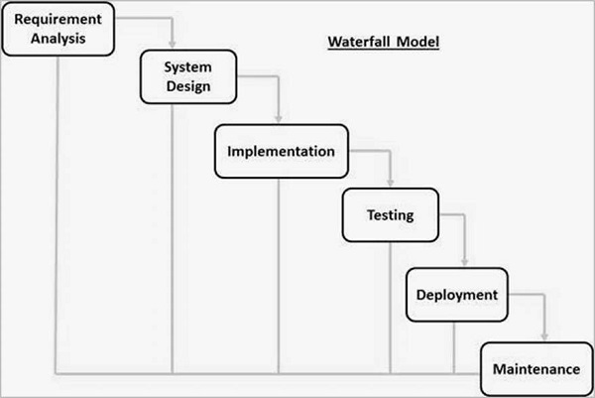

Figure: 1.1 Waterfall Development Model

Waterfall approach was first SDLC Model to be used widely in Software Engineering to ensure success of the project. In "The Waterfall" approach, the whole process of software development is divided into separate phases. In this Waterfall model, typically, the outcome of one phase acts as the input for the next phase sequentially.

* 1. **Contributions**

A numbers of novel concepts have been incorporated to the system. A keyword-matching algorithm and network traffic analysis algorithm with pattern finding approaches are used. There are numerous number of hidden testing procedure are followed.

**1.6 Outline of Dissertation**

This report is divided into several chapters.

**Chapter Two** covers the literacy review, which gives an overview of virtual client control and how an autonomous machine can learn from its mistake and knowledge base and make correction on the process.

**Chapter Three** explain how the current existed system work follow procedure and used their knowledge from there datacenter to solve different thread problem and suggest user with proper guidelines.

**Chapter Four** gives system designer to find the basic and baseline structure of prototype models and the analysis it’s risk management and control their proper specifications.

**Chapter Five** Describe how the new proposed system will work, response and features it offers. Proposed System’s flowchart, data flow diagram, and upgradation structure and prototype analysis.

* 1. **Summary**

A numbers of novel concepts have been incorporated to the system. A keyword-matching algorithm and network traffic analysis algorithm with pattern finding approaches are used. There are numerous number of hidden testing procedure are followed.

**Chapter 2**

**LITARACY REVIEW**

**Literacy Review**

This chapter covers the basic background literacy study for developing our system with latest system pros, cons, and there affect current world business and other institutional uses. There are also descriptions about what are the main components, risk & concerns when designing this system.

* 1. **Introduction of ERP Systems**

ERP stands for Enterprise Resource Planning. ERP is an enterprise-wide information system that facilitates the flow of information and coordinates all resources and activities within the business organization. Functions typically supported by the system include manufacturing, inventory, shipping, logistics, distribution, invoicing, and accounting. Some solutions now embed customer relationship management functionality. A wide variety of business activities including sales, marketing, billing, production, inventory management, human resource management, and quality control depend on these systems. The ERP system assists in managing the connections to outside stakeholders as well as enhancing performance management. It uses a centralized database and usually relies on a common computing platform. It provides the user a unified, consistent, uniform environment. ERP solutions evolved from applications focused on materials requirements and resource planning and computer integrated manufacturing. The Enterprise Resource Planning term came about when software developers were searching for a name that would more aptly describe these broader systems. These new solutions provided functionality that encompassed other applications in addition to manufacturing.

Of all the software an organization can deploy, ERP has potentially the most direct impact on reducing costs. When asked in a 2010 survey conducted by the Aberdeen Group of Small and Medium Businesses (SMBs) what factors drove them to implement an ERP solution, nearly half cited the need to reduce costs to improve operating margins. Improving customer service was the second most cited reason. The distribution of responses to this survey appears below in Figure1:

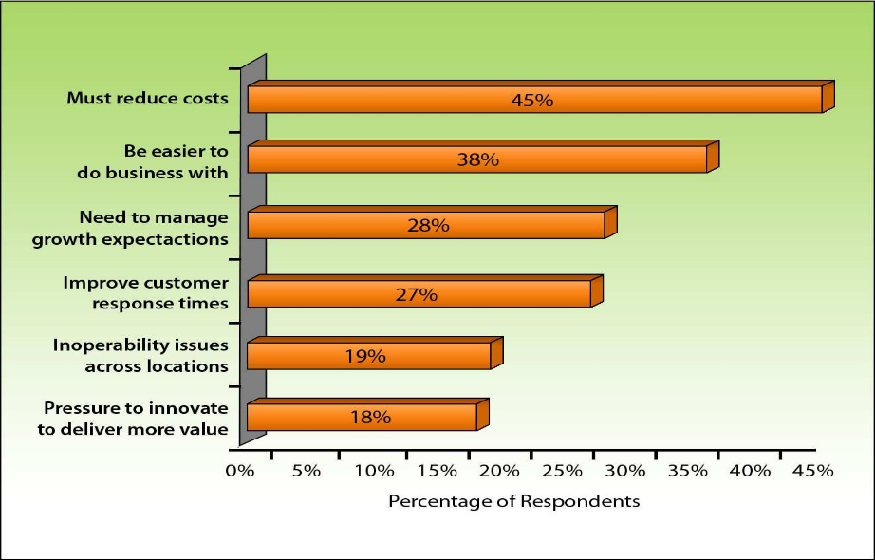

Figure 1: Factors Driving ERP Adoption

A survey conducted during much the same period by AMR Research confirms these findings. Fifty percent of their respondents named cost reduction and improved efficiencies between their top two priorities.

* 1. **Evolution of ERP systems**

The evolution of ERP systems closely followed the spectacular developments in the field of computer hardware and software systems. During the 1960s, most organizations designed, developed and implemented centralized computing systems, mostly automating their inventory control systems using inventory control packages (IC). These were legacy systems based on programming languages such as COBOL, ALGOL and FORTRAN. Material requirements planning (MRP) systems were developed in the 1970s, which involved mainly planning the product or parts requirements according to the master production schedule. Following this route new software systems called manufacturing resources planning (MRP II) were introduced in the

1980’s with an emphasis on optimizing manufacturing processes by synchronizing the materials with production requirements. MRP II included areas such as shop floor and distribution management, project management, finance, human resource and engineering. ERP systems first appeared in the late 1980s and the beginning of the 1990s with the power of enterprise-wide inter-functional coordination and integration. Based on the technological foundations of MRP and MRP II, ERP systems integrate business processes including manufacturing, distribution, accounting, financial, human resource management, project management, inventory management, service and maintenance, and transportation, providing accessibility, visibility and consistency across the enterprise.

During the 1990s, ERP vendors added more modules and functions as “add-ons” to the core modules giving birth to the “extended ERPs.” These ERP extensions include advanced planning and scheduling (APS), e-business solutions such as customer relationship management (CRM) and supply chain management (SCM). Figure 2 summarizes the historical events related with ERP.

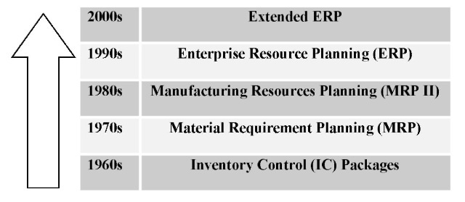

Figure2: Evolution of ERP System

* 1. **ERP Systems Architecture**

ERP vendors, mostly experienced from the MRP and financial software services fields, realized the limitations of the old legacy information system used in large enterprises of the 1970s and 1980s. Some of these old systems were developed in-house while different vendors using several different database management systems, languages and pack- ages, creating islands of no compatible solutions unfit for seamless data flow between them, developed others. It was difficult to increase the capacity of such systems or the users were unable to upgrade them with the organization’s business changes, strategic goals and new information technologies.

An ERP system is required to have the following characteristics:

* Modular design comprising many distinct business modules such as financial, manufacturing, accounting, distribution, etc.
* Use centralized common database management system (DBMS)
* The modules are integrated and provide seamless data flow among the modules, increasing operational transparency through standard interfaces
* They are generally complex systems involving high cost
* They are flexible and offer best business practices
* They require time-consuming tailoring and configuration setups for integrating with the company’s business functions
* The modules work in real time with online and batch processing capabilities
* They are or soon they will be Internet-enabled

Different ERP vendors provide ERP systems with some degree of specialty but the core modules are almost the same for all of them. Some of the core ERP modules found in the successful ERP systems are the following:

* Accounting Management
* Financial Management
* Manufacturing Management
* Production Management
* Transportation Management
* Sales & Distribution Management
* Human Resources Management
* Supply Chain Management
* Customer Relationship Management
* E-Business

The modules of an ERP system can either work as stand-alone units or several modules can be combined together to form an integrated system. The systems are usually designed to operate under several operating platforms such as UNIX, MS Windows NT, and Windows 2000, IBM AIX, and HP-UX systems. SAP AG, the largest ERP vendor, provides a number of modules with its famous R/3 ERP system, which are shown in Table 3. New modules are introduced by SAP and other vendors in response to the market and technological demand such as the Internet technology.

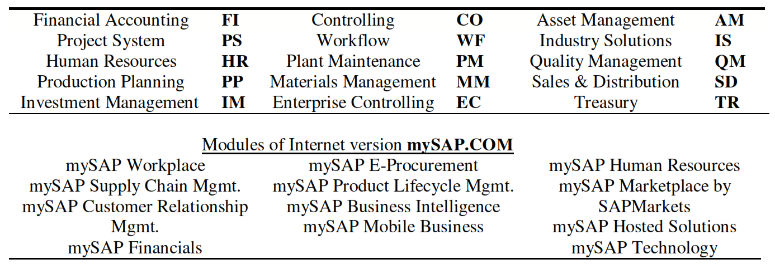

Figure 3: Some modules of SAPs/R3 ERP Systems

Enterprise systems employ thin client/server (C/S) technology or client/ fat server (C/FS) architecture, creating a decentralized computing environment. In a C/S system a number of client devices operated by end users such as desktop PCs request services from application servers, which in turn get the requested service-related information from the database servers. The requests may be simple data files, data values, communication services, transaction processing or master file updates.

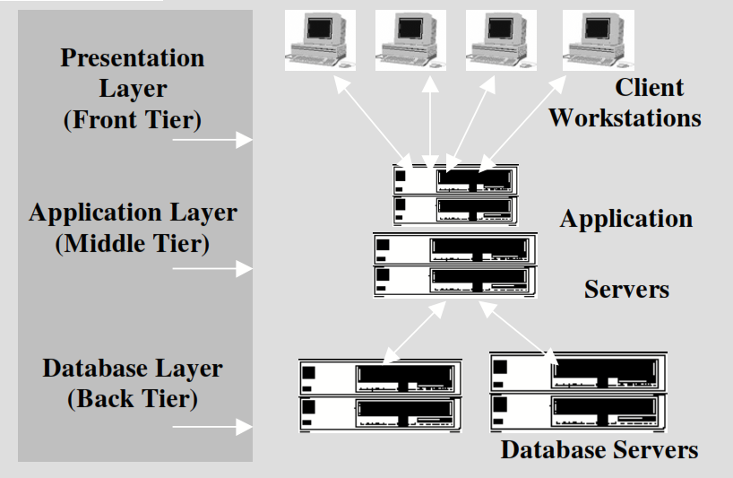

Figure 4: n-tier Deployment Architecture

The general practice is to have three-tier architecture such as in Figure: 4. in this three-tier system the user interface runs on the client. To run ERP systems relatively powerful PCs (clients) and powerful servers are required where most of the hundreds of thousands of operations are performed. The client/server system functions are performed following three layers of logic:

* **Presentation Layer:** Graphical user interface (GUI) or browser for data entry or accessing system functions
* **Application Layer:** Business rules, functions, logic, and programs acting on data received/transferred from/to the database servers
* **Database Layer:** Management of the organization’s operational or transactional data including metadata; mostly employs industry standard RDBMS with structured query language (SQL) provisions

This logical arrangement helps the ERP user interface to run on the clients, the processing modules to run on the middle-tier application servers, and the database system to run on the database servers.

* 1. **ERP Systems And Organizations**

It is generally a misleading perception that implementing an ERP system will improve organizations’ functionalities overnight. The high expectation of achieving all-round cost savings and service improvements is very much dependent on how good the chosen ERP system fits to the organizational functionalities and how well the tailoring and configuration process of the system matched with the business culture, strategy and structure of the organization. Overall, an ERP system is expected to improve both backbone and front-end functions simultaneously. Organizations choose and deploy ERP systems for many tangible and intangible benefits and strategic reasons. In many cases, the calculation of return on investment (ROI) is weighted against the many intangible and strategic benefits.

The benefits that an industry standard ERP system may bring to organizations are show in Table 1.

|  |  |
| --- | --- |
| **Advantages** | **How** |
| Reliable Information Access. | Common DBMS, consistent and accurate data, improved reports. |
| Avoid Data And Operations. | Modules access same data from the central database, avoids multiple data input and update operations. |
| Delivery And Cycle Time Reduction | Minimizes retrieving and reporting Protocols. |
| Cost Reduction | Time-saving, improved control by enterprise-wide analysis of organizational decisions. |
| Easy Adaptability | Changes in business processes easy to adapt and restructure |
| Improved Scalability | Structured and modular design with “add- ons.” |
| Improved Maintenance | Vendor-supported long-term contract as part of the system procurement |
| Global Outreach | Extended modules such as CRM and Other Systems |
| E-Commerce, E-Business | Internet commerce, collaborative culture |

Table 1: Advantages of ERP System

To reap the benefits of ERP systems, however, organizations need to overcome certain problems and disadvantages, which are listed in Table 2.

|  |  |
| --- | --- |
| **Disadvantage** | **How to overcome** |
| Time-consuming | Minimize sensitive issues, internal politics and raise consensus. |
| Expensive | Cost may vary from thousands of dollars to millions. Business process reengineering cost may be extremely high. |
| Conformity of the modules | The architecture and components of the selected system should conform to the business processes, culture and strategic goals of the organization. |
| Vendor dependence | Single vendor vs. multi-vendor consideration, options for “best of breeds,” long-term committed support. |
| Features and complexity | ERP system may have too many features and modules so the user needs to consider carefully and implement the needful only. |
| Scalability and global outreach | Look for vendor investment in R&D, long- term commitment to product and services, consider Internet-enabled systems. |
| Extended ERP capability | Consider middle-ware “add-on” facilities and extended modules such as CRM and SCM. |

Table2: Disadvantages of ERP Systems and its Overcomes

It was estimated that the spending on ERP systems in 1998 was about US$17 billion following annual growth rates ranging from 30% to 50%. Companies also spend a multiple of licensing costs on services related to implementation and maintenance of the software. The worldwide license and maintenance revenue for ERP systems was US$21.5 billion in 2000, which represented a growth of 13.1% from the 1999 market value of $US19 billion (Broatch, 2001). The continued growth of the ERP systems market is attributed to the fact that the vendors are adding applications such as supply chain management, customer relationship management and the integration of Internet-enabled applications for e-business.

More than 60% of the Fortune 1000 companies have installed or are in the process of implementing packaged ERP systems to support their back-end business activities (Kraft, 2001). These packages implemented by the Fortune 1000 companies run well over the IT budgets for most SMEs. ERP vendors are targeting this untapped SME market with supposedly scaled-back systems suitable for smaller firms by offering simple, cheaper and pre-configured easy-to-install solutions within budget and time constraints. For some vendors this may lead to offering centrally managed Internet-enabled ERP-system-based services for SMEs to access and use anytime from anywhere.

**2.5**

**2.10 Waterfall SDLC Model**

Waterfall approach was first SDLC Model to be used widely in Software Engineering to ensure success of the project. In "The Waterfall" approach, the whole process of software development is divided into separate phases. In this Waterfall model, typically, the outcome of one phase acts as the input for the next phase sequentially.

The following illustration is a representation of the different phases of the Waterfall Model.



The sequential phases in Waterfall model are −

* **Requirement Gathering and analysis** − All possible requirements of the system to be developed are captured in this phase and documented in a requirement specification document.
* **System Design** − The requirement specifications from first phase are studied in this phase and the system design is prepared. This system design helps in specifying hardware and system requirements and helps in defining the overall system architecture.
* **Implementation −** with inputs from the system design, the system is first developed in small programs called units, which are integrated in the next phase. Each unit is developed and tested for its functionality, which is referred to as Unit Testing.
* **Integration and Testing** − All the units developed in the implementation phase are integrated into a system after testing of each unit. Post integration the entire system is tested for any faults and failures.
* **Deployment of system −** Once the functional and non-functional testing is done; the product is deployed in the customer environment or released into the market.
* **Maintenance −** There are some issues which come up in the client environment. To fix those issues, patches are released. In addition, to enhance the product some better versions are released. Maintenance is done to deliver these changes in the customer environment.

All these phases are cascaded to each other in which progress is seen as flowing steadily downwards (like a waterfall) through the phases. The next phase is started only after the defined set of goals are achieved for previous phase and it is signed off, so the name "Waterfall Model". In this model, phases do not overlap.

**2.11 Waterfall Model - Application**

Every software developed is different and requires a suitable SDLC approach to be followed based on the internal and external factors. Some situations where the use of Waterfall model is most appropriate are −

* Requirements are very well documented, clear and fixed.
* Product definition is stable.
* Technology is understood and is not dynamic.
* There are no ambiguous requirements.
* Ample resources with required expertise are available to support the product.
* The project is short.

**2.12 Waterfall Model - Advantages**

The advantages of waterfall development are that it allows for departmentalization and control. A schedule can be set with deadlines for each stage of development and a product can proceed through the development process model phases one by one. Development moves from concept, through design, implementation, testing, installation, troubleshooting, and ends up at operation and maintenance. Each phase of development proceeds in strict order. Some of the major advantages of the Waterfall Model are as follows −

* Simple and easy to understand and use
* Easy to manage due to the rigidity of the model. Each phase has specific deliverables and a review process.
* Phases are processed and completed one at a time.
* Works well for smaller projects where requirements are very well understood.
* Clearly defined stages.
* Well understood milestones.
* Easy to arrange tasks.
* Process and results are well documented.

**2.13 Waterfall Model - Disadvantages**

The disadvantage of waterfall development is that it does not allow much reflection or revision. Once an application is in the testing stage, it is very difficult to go back and change something that was not well documented or thought upon in the concept stage.

The major disadvantages of the Waterfall Model are as follows −

* No working software is produced until late during the life cycle.
* High amounts of risk and uncertainty.
* Not a good model for complex and object-oriented projects.
* Poor model for long and ongoing projects.
* Not suitable for the projects where requirements are at a moderate to high risk of changing. Therefore, risk and uncertainty is high with this process model.
* It is difficult to measure progress within stages.
* Cannot accommodate changing requirements.
* Adjusting scope during the life cycle can end a project.
* Integration is done as a "big-bang. At the very end, which does not allow identifying any technological or business bottleneck or challenges early.

**Chapter 3**

**EXISTING SYSTEMS**

**Existing Systems**

This chapter covers the basic study of currently developed and commercially used ERP systems with their pros, cons, and there affect current world business and other institutional uses. There are also descriptions about what are the main components, risk & concerns when designing this system.

**3.1 Commercial ERP Systems**

The five dominating ERP software suppliers are SAP, Oracle, PeopleSoft, Baan and J.D. Edwards. Together they control more than 60% of the multi- billion dollar global market. Each vendor, due to historic reasons, has a specialty in one particular module area such as Baan in manufacturing, PeopleSoft in human resources management, SAP in logistics and Oracle in financials. There are also about 50 established and a few more newly emerging smaller and midsize ERP vendors including third-party developers competing for the ERP market. The result is stiff competition and feature-overlapping products difficult to differentiate.

Due to keen competition for control of the lucrative ERP market share, the vendors are continuously updating their products and adding new technology-based features. Long-term vision, commitment to service and support, module features, specialty, experience and financial strength for R&D are considered the major vendor qualities for product selection and turnkey implementation. In the following sections, we provide brief profiles of these five ERP giants.

**3.1.1 SAP AG–Flagship Products R/3**

SAP AG (“Systeme, Anwendungen, und Produkte in Datenverarbeitung”), or Systems, Applications and Products in Data Processing, was started by five former IBM engineers in Germany in 1972 for producing integrated business application software for the manufacturing enterprise (SAP, 2001). Its first ERP product, R/2, was launched in 1979 using a mainframe-based centralized database that was then redesigned as client/server software R/3 in 1992. System R/3 was a breakthrough and by 1999 SAP AG became the third largest software vendor in the world and the largest in the ERP sector with a market share of about 36% serving over 17,000 customers in over 100 countries.

In 1999 SAP AG extended the ERP functions by adding CRM, SCM, sales-force automation and data warehousing. SAP has also invested significantly in its R&D sector with the result of newer versions of R/3 3.1, 4.0, 4.6 including Internet functionalities and other enhancements. SAP’s Internet-enabled ERP solutions are provided by the recently launched ERP product called mySAP.COM. SAP has the broadest ERP functionality, capacity to spend significantly on R&D, strong industry-focused solutions and long-term vision.

**3.1.2 Oracle Corporation–Flagship Product *Oracle Applications***

Oracle (Oracle, 2001), founded in 1977 in the USA, is best known for its database software and related applications and is the second largest software company in the world after Microsoft. Oracle’s enterprise software applications started to work with its database in 1987. It accounts for $2.5 billion out of the company’s $9.3 billion in 1999, which places Oracle second to SAP in the enterprise systems category with over 5,000 customers in 140 countries. Oracles ERP system is known as Oracle Applications, having more than 50 different modules in six major categories: finance, accounts payable, human resources, manufacturing, supply chain, projects and front office. Oracle has other strong products in the software field including DBMS, data warehousing, workflow, systems administration, application development tools (APIs), and consulting services. A notable feature of Oracle is that it is both a competitor and a partner to some of the industry leaders in the ERP market such as SAP, Baan and PeopleSoft because of the use of Oracle’s DBMS in their ERP systems.

Oracle has integrated its ERP solutions with the Internet and has introduced several applications in the electronic commerce and Internet- based commerce areas. Oracle’s Internet infrastructure was created around two powerful products: Oracle9i Database and Oracle9i Application Server. Another significant feature of Oracle is its OSBS, or Oracle Small Business Suite which provides consistent financials, payroll, inventory control, order entry, purchase orders, and CRM functionality–all delivered as a Web service. Oracle also offers an easy-to-activate Web presence that helps companies to sell their goods via the Internet.

**3.1.3 PeopleSoft Inc.–Flagship Product *PeopleSoft8***

PeopleSoft is one of the newest ERP software firms started in 1987 in Pleasanton, California, with specialization in human resource management and financial services modules. PeopleSoft quickly managed to offer other corporate functions and attained a revenue of $32 million in 1992. Enterprise.

Solutions from PeopleSoft include modules for manufacturing, materials management, distribution, finance, human resources and supply chain planning. SAP AG and Oracle–with longer experience, stronger financial base and worldwide presence–are the main competitors to PeopleSoft. Many customers comment that PeopleSoft has a culture of collaboration with customers, which makes it more flexible than its competitors do. One of the strengths of PeopleSoft is the recognition by its customers that it is flexible and collaborative. PeopleSoft developed the flagship application PeopleSoft8 with scores of applications with an expenditure of $500 million and 2,000 developers over 2 years as a pure Internet-based collaborative enterprise system. “Our revolutionary E-Business platform is the first open XML platform to offer scalability and ease of use for all users.

PeopleSoft 8 requires no client software other than a standard Web browser, giving you the ability to securely run your business anytime, anywhere” (PeopleSoft, 2001). “Our eBusiness applications and consulting services enable true global operations–managing multiple currencies, languages, and business processes for more than 4,400 organizations in 109 countries” (PeopleSoft, 2001). PeopleSoft with about 10% market share is the third largest ERP vendor after SAP AG and Oracle.

**3.1.4 The Baan Company–Flagship Product *BaanERP***

Founded in 1978 in The Netherlands, Baan (Baan, 2001) started with expertise in software for the manufacturing industry and by 1997 claimed an ERP market share of roughly 5%. Bann’s revenue in 1998 was roughly $750 million and while facing a slight slowdown in 1999 started growing again in 2001 with sales up 12% at £7,231million and operating profit of £926 million. Baan has more than 15,000 customer sites all over the world and more than 3,000 employees. Baan believes that “the Internet is the ultimate enabler” and “Internet technologies help companies become order-driven and customer- focused by enabling collaboration across the ‘value chain.’ Suppliers, distributors, manufacturers and customers can work together to deliver the right product at the right price.”

ERP solution areas that Baan covers include finance, procurement, manufacturing, distribution, integration and implementation, planning, sales, service and maintenance, business portals, collaborative commerce and business intelligence. Bann’s flagship product is BaanERP (formerly called Triton, then Baan IV), launched in 1998. One innovative product from Baan is the Orgware tool that can cut implementation cost significantly by automatically configuring the enterprise software. Baan’s ERP software best known in the aerospace, automotive, defence and electronics industries.

**3.1.5 J.D. Edwards & Co.–Flagship Product *OneWorld***

J.D. Edwards was founded in 1977 in Denver (cofounded by **J**ack Thompson, **D**an Gregory and C. **Edward** McVaney) with long experience of supplying software for the AS/400 market. J.D. Edwards’ flagship ERP product called OneWorld is “capable of running on multiple platforms and with multiple databases and revolutionizes enterprise software by liberating users from inflexible, static technologies” (JD Edwards, 2001). The product includes modules for finance, manufacturing, distribution/logistics and human resources, quality management, maintenance management, data warehousing, customer support and after-sales service. J.D. Edwards’ revenue jumped to $944 million in 1999 from $120 million in1992, having more than 5,000 customers in over 100 countries. The OneWorld system is considered more flexible than similar competing products and within the reach of smaller enterprises. J.D. Edwards’ Internet-extended version of OneWorld was launched recently as OneWorld Xe (“Xe” stands for “ex- tended enterprise”).

**3.2 Extended ERPs**

The proliferation of the Internet has shown tremendous impact on every aspect of the IT sector including ERP systems becoming more and more “Internet-enabled” (Lawton, 2000). This environment of accessing systems resources from anywhere anytime has helped ERP vendors extend their legacy ERP systems to integrate with newer external business modules such as supply chain management, customer relationship management, sales force automation (SFA), advanced planning and scheduling (APS), business intelligence (BI), and e-business capabilities. In fact, ERP is becoming the e- business backbone for organizations doing online business transactions over the Internet. Internet-based solutions are destined to improve customer satisfaction, increase marketing and sales opportunities, expand distribution channels, and provide more cost-effective billing and payment methods. The extension to SCM and CRM enables effective tri-party business relationships between the organization, suppliers and the customers. A supply chain management has sub-modules for procurement of materials, transformation of the materials into products and distribution of products to customers. “Successful supply chain management allows an enterprise to anticipate demand and deliver the right product to the right place at the right time at the lowest possible cost to satisfy its customers. Dramatic savings can be achieved in inventory reduction, transportation costs and reduced spoilage by matching supply with actual demand” (IBM, 2001).

With the deployment of a CRM, organizations are able to gather knowledge about their custom ERP, opening opportunities to assess customer needs, values and costs throughout the business life cycle for better understanding and investment decisions. The sub-modules found in typical CRM packages are marketing, sales, customer service and support systems using Internet and other access facilities with the intention of increasing customer loyalty through improved customer satisfaction.

E-commerce is the conduct of business transactions among organizations with the support of networked information and communication technologies, especially utilizing Internet applications such as the Web and e- mail, effectively reaching global customers. Adoption of e-commerce and e- business solutions, especially business-to-business (B2B) solutions, are seen by many as the wave of current and future extensions of traditional ERP systems of most small, medium and large vendors. The front-end Web-based Internet-business applications are integrated with the back-office ERP-based applications, enabling business transactions such as order placement, purchasing, inventory updates, employee benefits, etc. to take place between the customers, suppliers and the enterprise based on reliable, relevant data and applications instantly in a border-less domain.

The legacy ERP systems designed to integrate enterprise functions within the four walls of the enterprise have introduced software solutions with a Web-interface essentially extending to Internet-enabled CRM, SCM and other Internet-business models. Examples of such extended ERPs are avail- able from most of the ERP vendors. Thus, SAP’s Internet-enabled integrated ERP system called mySAP.COM (SAP, 2001) is a suite of ERP, CRM and other products that can be linked together using Internet portals.

An example of an extended ERP system may be Oracle’s e-business suite of ERP systems that connects to CRM and SCM. Oracle’s Fast Forward Web Store (Oracle, 2001) provides applications for establishing online stores for handling transactions and services with the possibility of linking into Oracle’s ERP applications. ERP and e-commerce applications of an enterprise can share a common database with the deployment of Oracle Applications 11i (Oracle, 2001) integrating Web sites with ERP back-office applications. Baan has integrated its ERP, CRM and SCM with manufacturing management software. J.D. Edwards’ OneWorld ERP package is reengineered to OneWorld Xe (“Xe” stands for “extended enterprise”), which enables the organization to extend the enterprise beyond physical walls to collaborate with customers, partners, and suppliers with additional tools for business-to-business (B2B)

**Chapter 4**

**ANALYSIS AND REQUIREMENT SPECIFICATIONS**

**Analysis and Requirement Specifications**

This chapter covers the study of analysis of existing systems, their system structure, process and other specifications, break down thoroughly all the requirements for our proposed system, and proposed systems analysis block.

**4.1 Commercial ERP Systems**

The five dominating ERP software suppliers are SAP, Oracle, PeopleSoft, Baan and J.D. Edwards.

**Chapter 5**

**PROPOSED SYSTEM DESIGN**

**Proposed System Design**

This chapter covers the proposed system features & specification with modules or extension it can support and board connection with existing systems communication for legacy support.

**5.1 System Features**

This are the most targeted features we all proposing to develop in our enterprise resource planning system.

1. Admission Management
2. Fees Management
3. Department management
4. Library Management
5. Examination Monitoring
6. Staff Attendance & Payroll
7. Student Information System
8. Transportation
9. Employee Placement
10. Hostel & Accommodation
11. University & Trust board Control
12. Payment gateway
13. Additional feature
    1. Parent Info System
    2. Smart card / RFID card Support
    3. Hardware Automation Integration
    4. Third party /External API Integration

**5.1.1 Module: Admission Management**

1. Admission details of student
2. Cancellation / Re-admission of student
3. Student profile management
4. Branch transfer
5. Allocation of University Register No.
6. Allocation of Roll No.
7. Bulk upload of student photos
8. Admission related reports
9. Reports related to affiliated University

**5.1.2 Module: Fees Management**

1. Admission fees, academic fees (monthly, yearly), non-academic fees
2. Fixed portion and item wise charges, receipt printing, option of collecting fees by cash or DD or cheque
3. Challan issue, printing & confirmation
4. Batch-wise (year-wise) chart of fees structure
5. Automated fine calculation based on slabs & last date of payment
6. Collection of fees for previous & future terms
7. Account wise fee report
8. Integrated with relevant modules like Accounts, Student / Parent Information System
9. Refund of fees, re-printing of receipts & challan
10. Collection & due reports

**5.1.3 Module: Department Management**

1. Employee profile (both teaching and administrative),
2. Subject allocation,
3. weekly workload, syllabus for the year
4. Subject-wise headings and topics as per the university syllabus
5. Time Table for subjects and teaching stuff
6. Creation & assignment of sections
7. Maintenance of period-wise student attendance
8. Creation & assignment of practical batches
9. Schedule & assessment of internal marks
10. Assignment of elective papers
11. Project work/seminar assessment
12. Reports (internals, attendance, consolidated Internals & attendance, progress report etc.)
    * 1. **Module: Library Management**
13. Catalog and register of books, magazines, project reports, journals.
14. Item categorization - “For Issue”, “For Reference” and “Issue against Deposit”
15. Entry register
16. Issue / Return /Renewal of books, magazines etc.
17. Fine calculation
18. Main & department-wise libraries
19. Subject-wise categorization of library books
20. Author, publisher, binder and suppliers’ details
21. Lost book register
22. Re-issuing guidelines
23. Stock Verification
24. OPAC search
25. E Mail reminder to members
26. Reports- accession register, Issue / Return ledger, fine collected, overdue books etc.
    * 1. **Module: Examination Monitoring**
         1. Examination application form
         2. Exam fee collection Ë Exam eligibility
         3. Printing of hall ticket
         4. Statutory guidelines and syllabus as prescribed by the affiliated University
         5. University exam time table
         6. Student seat allocation for University exam
         7. Form A, Form B, Consolidated Absentees
         8. Examination marks entry
         9. Marks import from Excel, Access & Databases (pre-defined format)
         10. Grading calculation(relative & absolute)
         11. Statutory University reports & grade card printing
         12. Student promotion

**REFERENCES**

1. Armstrong, A. and Hagel, J., III. (1996). the real value of online communities. *Harvard Business Revie*w, 74(3), 134-141.
2. APICS (2001). American Production and Inventory Control Society (APICS), [*http://www.apics.org.*](http://www.apics.org)
3. Bakos, Y. (1998). The emerging role of electronic marketplaces on the Internet. *Communications of the AC*M, 41(8), 35-42
4. Bhattacherjee, A. (1999). SAP Implementation at Geneva Chemical, [*http://www.cob.asu.edu/fac/ABhatt/cases/Geneva.pdf.*](http://www.cob.asu.edu/fac/ABhatt/cases/Geneva.pdf)
5. Bingi, P., Sharma, M. K. and Godla, J. K. (1999). Critical issues affecting an ERP Implementation. *Information Systems Management*, 16(3), 7-14.
6. Broatch, M. (2001). Making the ERP connection. *Computerworld New Zealand*, July.
7. Butler, M. (1999). CRM is not magic bullet for customer loyalty. *Computerworld*, 33(34), 34.
8. Davenport, T. H. (1998). Putting the enterprise into the enterprise system.

*Harvard Business Review*, 76(4), 121-131.

1. Davenport, T. H. (2000). *Mission Critical: Realizing the Promise of Enter- prise Systems*. Boston, MA: Harvard Business School Press.
2. Holland, C. and Light, B. (1999). A critical success factors model for ERP

Implementation. *IEEE Software*, May/June, 30-36.

1. Kalakota, R. and Robinson, M. (1999). *e-Business Roadmap for Success*.
2. Boston, MA: Addison-Wesley.
3. Kraft, C. L. (2001). Executive ERP. [*http://www.oracle.com/oramag/profit/*](http://www.oracle.com/oramag/profit/)*99-May/index.html?p29ind.html.*
4. Kumar, K. and Van Hillsgersberg, J. (2000). ERP experiences and evolution.

*Communications of the ACM,* 43(4), 23-26.

1. Lawton, G. (2000). Integrating ERP and CRM via the Web. *SW Expert*.
2. Li, C. (1999). ERP packages: What’s next? *Information Systems Manage- ment*, 16(3), 31-35.
3. Norris, G., Dunleavy, J., Hurley, J. R., Ballis, D. and Hartley, K. M. (2000).
4. *E-Business and ERP: Transforming the Enterprise*. New York: John
5. Wiley & Sons. O’Leary, D. E. (2000). *Enterprise Resource Planning Systems : Systems, Life Cycle, Electronic Commerce, and Risk*. UK: Cambridge University Press.
6. Shields, M.G., (2001). *E-Business and ERP: Rapid Implementation and Project Planning*. New York: John Wiley & Sons.
7. Tadjer, R. (1998). Enterprise resource planning. *Internetweek*, Manhasset, April 13.